CH.7
Classical Design Mistakes:
- Reducing design time
- Feature creep
- Silver bullet syndrome
- Switching tools in mid-project
Outsourcing Guidelines
• Keep the lines of communication open between you and your outsourcer.
• Define and stabilize requirements before signing a contract.
• View the outsourcing relationship as a partnership.
• Select the vendor, developer, or service provider carefully.
• Assign a person to manage the relationship.
• Don’t outsource what you don’t understand.
• Emphasize flexible requirements, long-term relationships, and short-term contracts.
Selecting a Design Strategy:
- Consider each of the following when deciding what strategy to use:
  - Business need
  - In-house experience
  - Project skills
  - Project management
  - Time frame
Selecting an Acquisition Strategy: “To get software from outside”
- Once a project team has a good understanding of how well each acquisition strategy fits with the project’s needs, it must begin to understand exactly how to implement these strategies.
- One helpful tool is the request for proposal (RFP), a document that solicits a formal proposal from a potential vendor, developer, or service provider
- For smaller projects with smaller budgets, the request for information (RFI) may be sufficient, as it is shorter and less detailed.
- A request for quote (RGQ) may be used when a list of equipment is so complete that the vendor only need provide a price.

CH.8
Architectural Design Purpose:
- Determine what parts of the application software will be assigned to what hardware.
Client-Server Architectures:
- Server-based Architecture
- Client-based Architecture
- Client-server based Architecture
Server-Based Architecture:
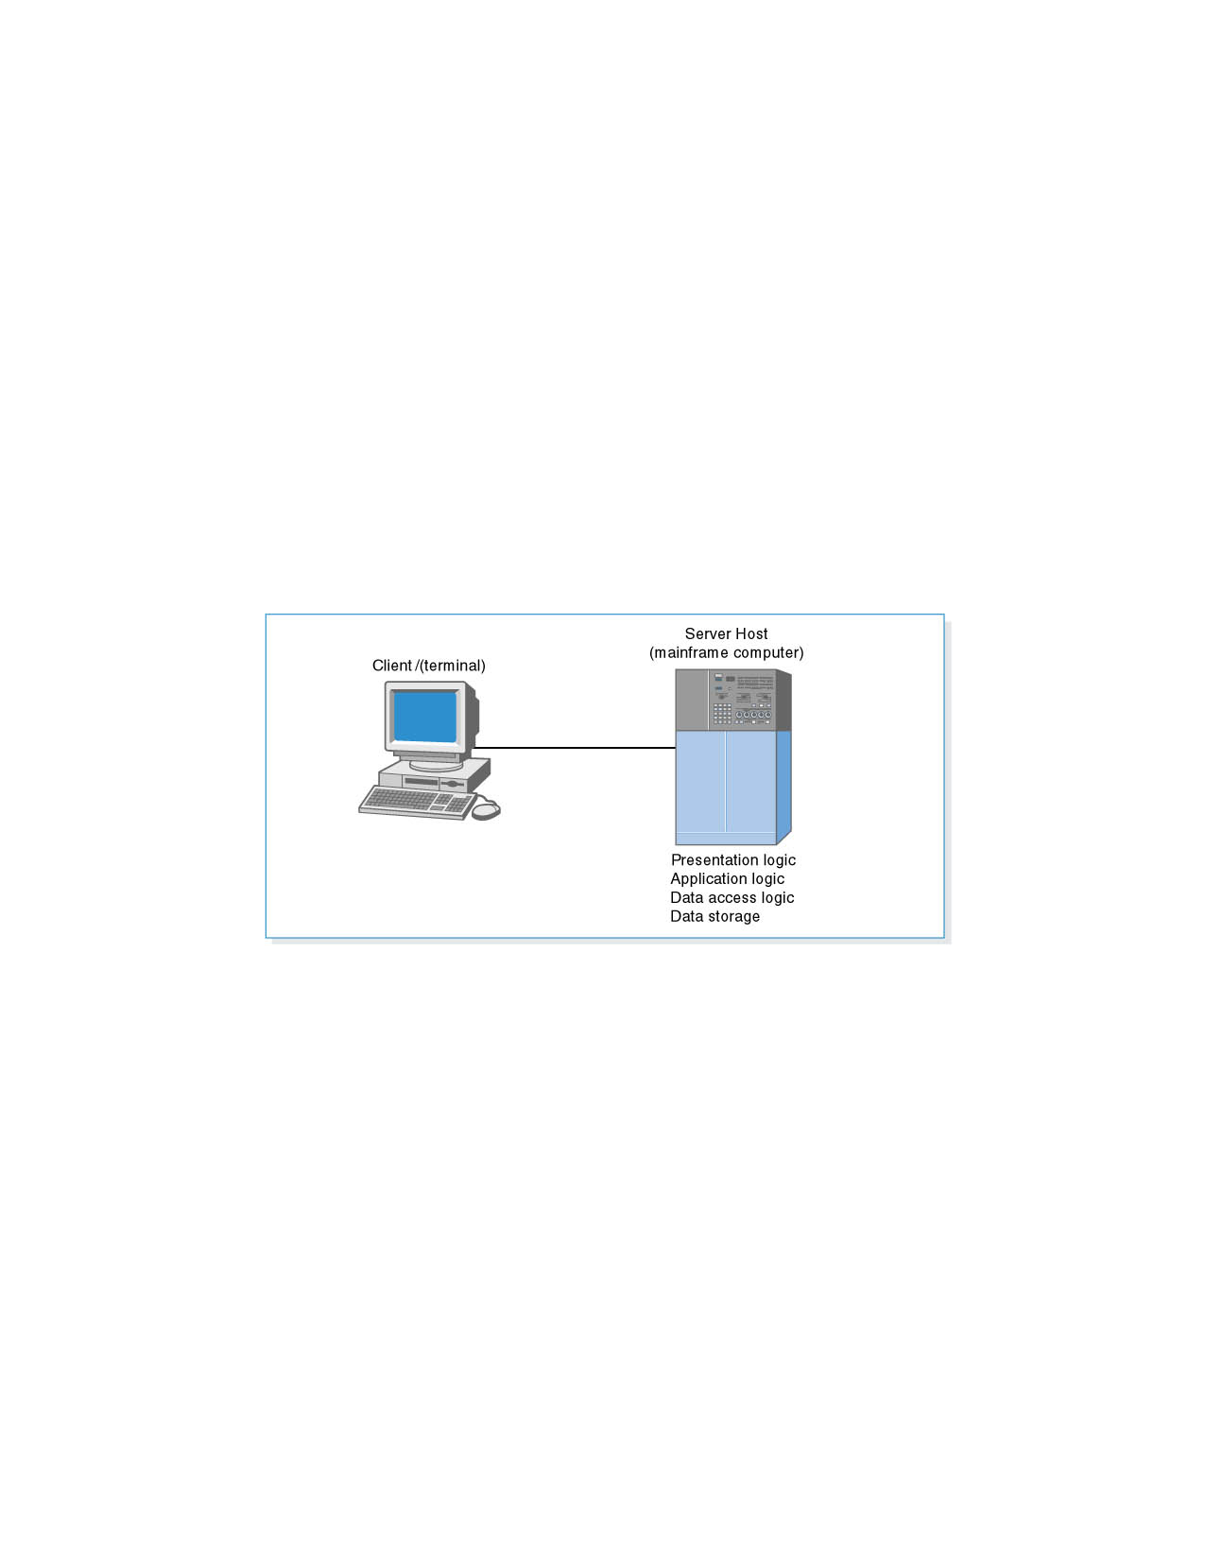
Client-Based Architecture:
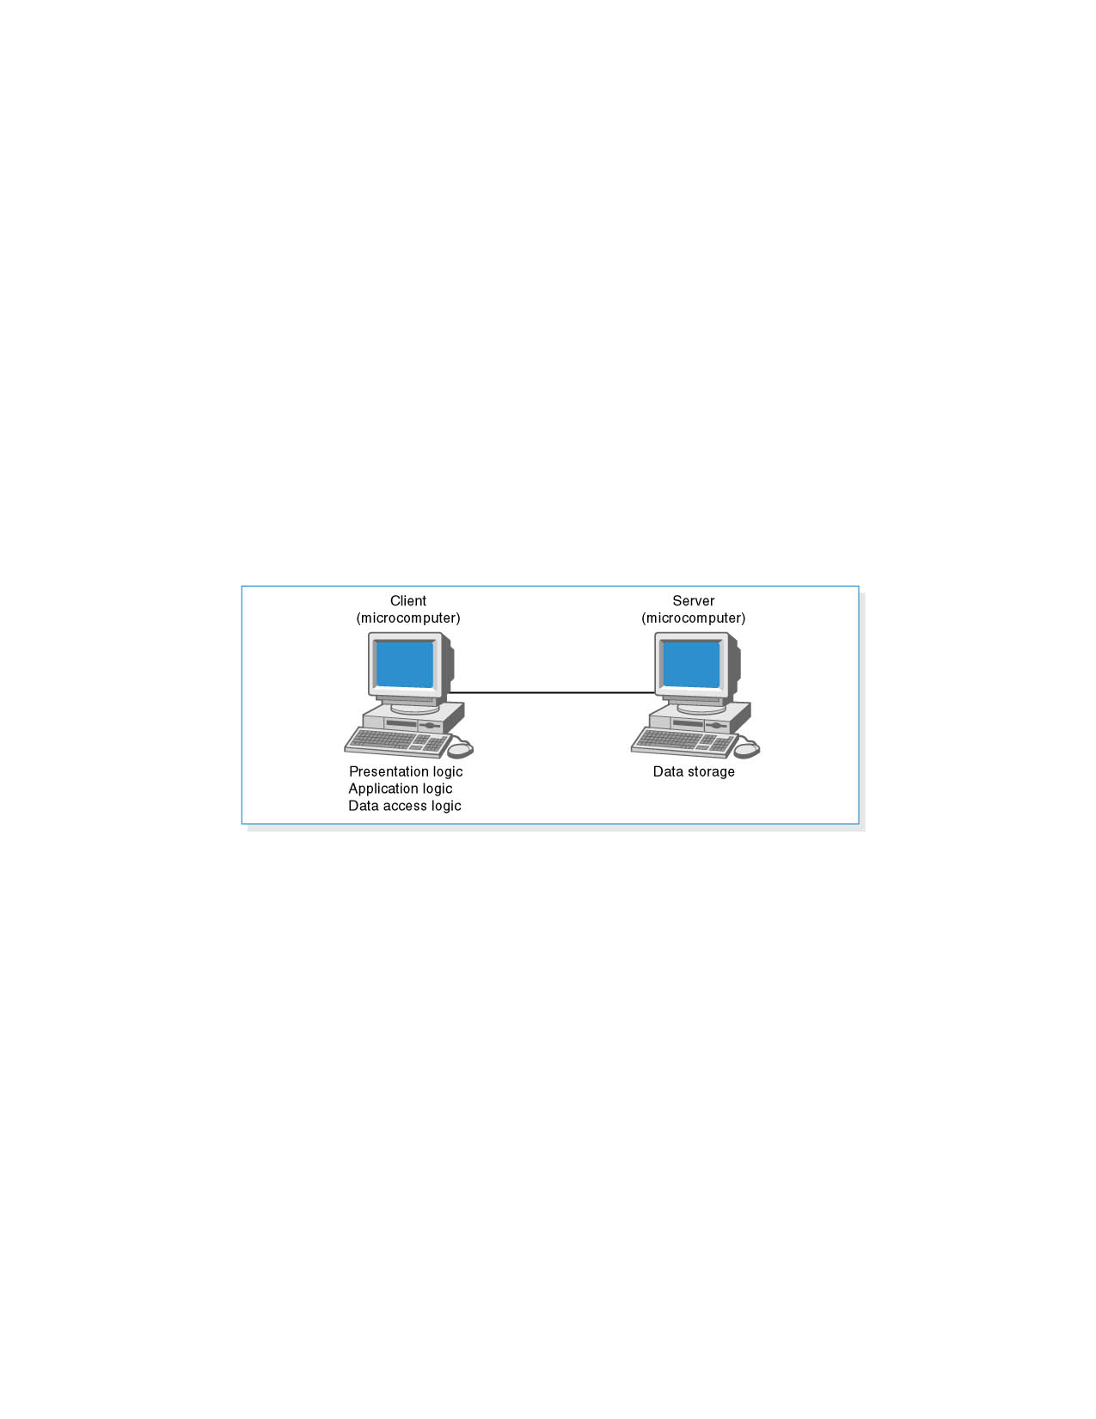
Client-Server Architecture (Two-Tiered)
If the clients contains all or most of the application logic, it is referred to as a thick or fat client. Currently, thin clients, containing just a small portion of the application logic, are popular because of lower overhead and easier maintenance.
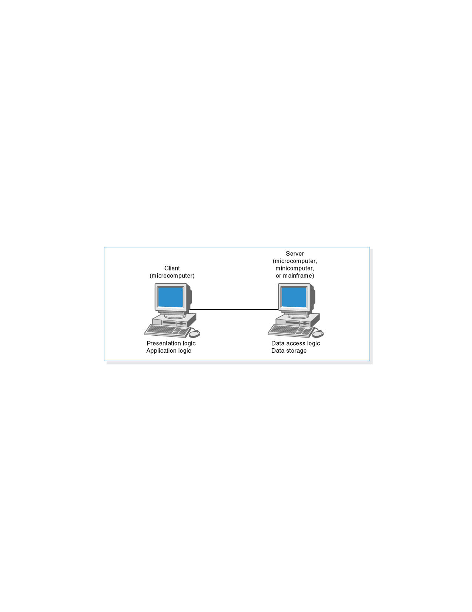
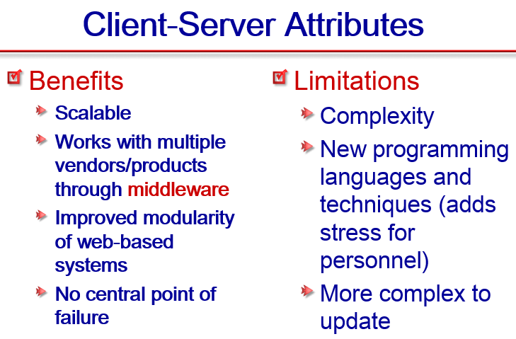
Three-Tiered Client-Server Architecture:
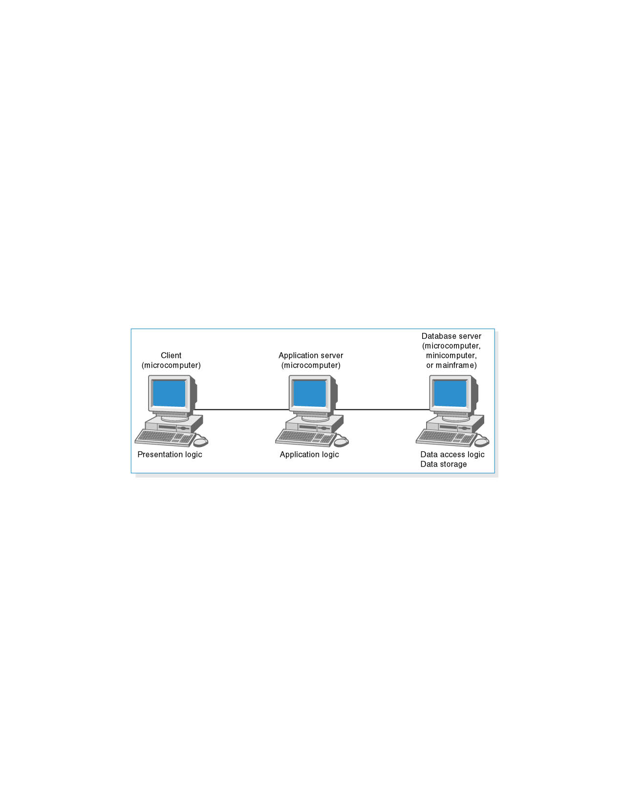
Four-Tiered Client-Server Architecture:
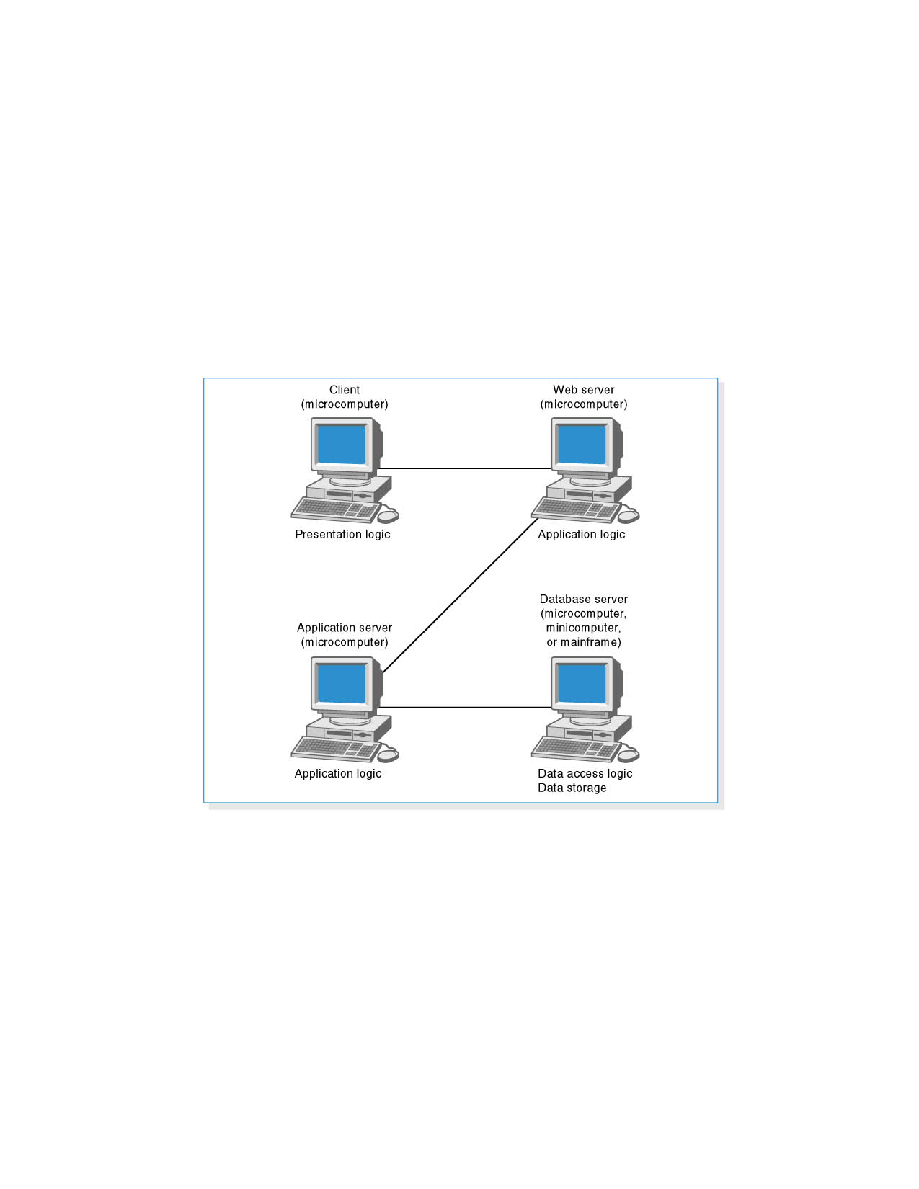

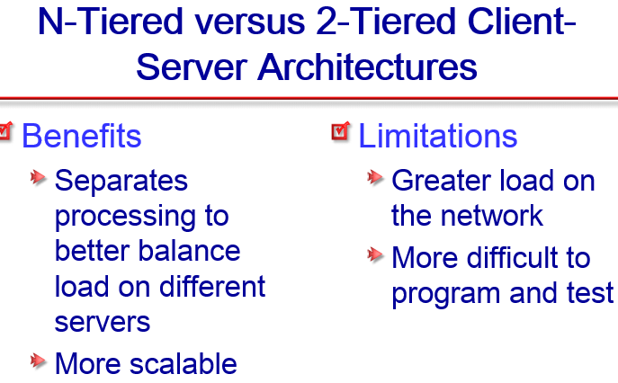

What’s the list of the Operational Requirements?
    - Technical Environment requirements
    - System Integration requirements
    - Portability requirements
    - Maintainability requirements

What’s the list of the Performance Requirements?
    - Speed requirements
    - Capacity requirements
    - Availability and Reliability requirements

What’s the list of the Security Requirements?
    - System Value Estimates
    - Access Control requirements
    - Encryption and Authentication requirements
    - Virus Control requirements

What’s the list of the Cultural/Political Requirements?
    - Multilingual requirements
    - Customization requirements
    - Making Unstated Norms Explicit
    - Legal requirements

CH.9
List the Principles for User Interface Design?
- Layout
- Content awareness
- Aesthetics
- User experience
- Consistency
- Minimize user effort

List the Principles for Content Awareness:
- Areas and information should minimize user movement from one to another
- Ideally, areas will remain consistent in
  - Size
  - Shape
  - Placement for entering data
  - Reports presenting retrieved data
List the Principles for Layout Concepts:
- The screen is often divided into three boxes
  - Navigation area (top)
  - Status area (bottom)
  - Work area (middle)
- Information can be presented in multiple areas
- Like areas should be grouped together
- Areas and information should minimize user movement from one to another
- Ideally, areas will remain consistent in: Size, Shape, Placement for entering data, and Reports presenting retrieved data
List the Principles for Aesthetics:
- Interfaces need to be functional and inviting to use
- Avoid squeezing in too much, particularly for novice users
- Design text carefully
  - Be aware of font and size
  - Avoid using all capital letters
- Colors and patterns should be used carefully

List the Principles for User Experience:
- How easy is the program to learn?
- How easy is the program to use for the expert?
- Consider adding shortcuts for the expert
- Where there is low employee turnover, some training can lessen the impact of less precise interfaces
List the Principles for Consistency:
- Enables users to predict what will happen
- Reduces learning curve
- Considers items within an application and across applications
- Pertains to many different levels
  - Navigation controls
  - Terminology
  - Report and form design
List the Principles for Minimize User Effort: Three clicks rule
  - Users should be able to go from the start or main menu of a system to the information or action they want in no more than three mouse clicks or three keystrokes

CH.10
The Physical Data Flow Diagram:
- The physical DFD contains the same components as the logical DFD, and the same rules apply, but the Physical DFD contains additional details that describe how the system will be built.
- The Physical DFD purpose to transform DFD in such of way that implantation details can be seen.
What are the Steps to Create the Physical Data Flow Diagram?
    - Add implementation references.
    - Draw a human–machine boundary.
    - Add system-related data stores, data flows, and processes.
    - Update the data elements in the data flow.
    - Update the metadata in the CASE repository.

The Structure Chart: IMPORTANT
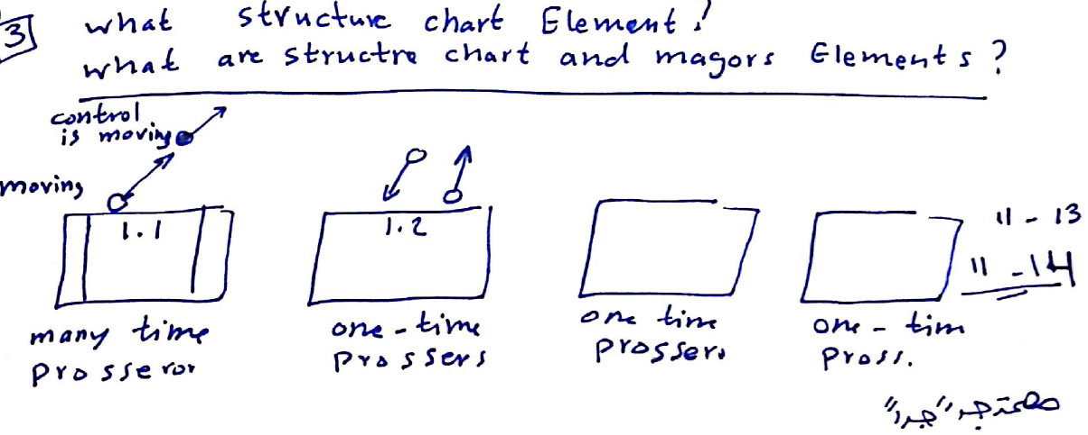
What’s the structure chart shows all the functional components that must be included in the program at a high level, arranged in a hierarchical format that implies order and control.
- Important program design technique
- Shows all components of code in a hierarchical format
  - Sequence
  - Selection
  - Iteration
What’s the important Structure Chart Elements: IMPORTANT
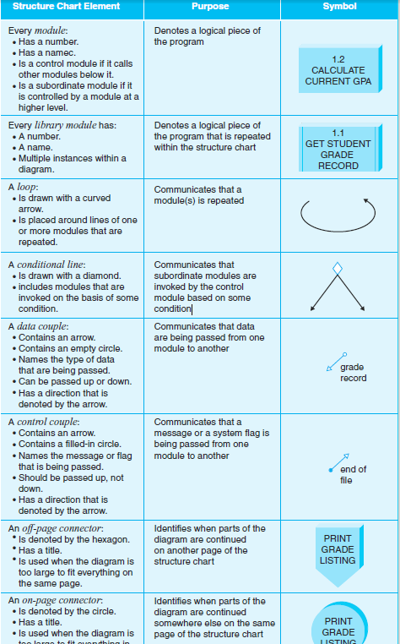
Structure Chart Example:
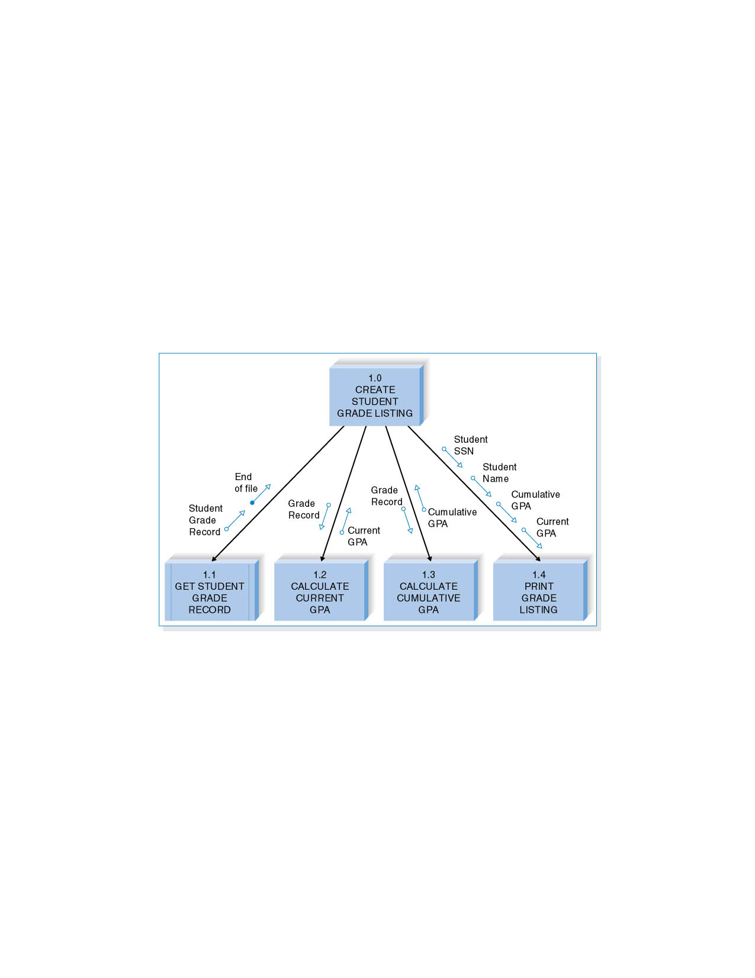
What’s the types of Structures and the difference?
    - Transform Structures.
    - Transaction Structures.
Transaction Structures: | Transform Structures:
- Few afferent processes  - Many efferent processes  - Higher levels of the structure chart  - Concerned with coordinating the production  of outputs | - Many afferent processes  - Few efferent processes  - Lower levels of the structure chart  - Concerned with using inputs to create  a new output

Define the Cohesion refers to how well the lines of code within each structure chart module relate to each other. “The pounding between the sub components”.
Describe what’s the good cohesion? In a good system it’s have high cohesion.

Define the Coupling involves how closely modules are interrelated, and the second guideline for good structure chart design states that modules should be loosely coupled.
“The pounding between the components”.
Describe what’s the good Coupling? In a good system there is low coupling but never have zero.

CH.11

What are the types of Data Storage Formats?
- Files: electronic lists of data optimized to perform a particular transaction
- Database: a collection of groupings of information that relate to each other in some way.
- A Database Management System (DBMS) is software that creates and manipulates databases.
What are the Attributes of a file?
- Files contain information formatted for a particular transaction
- Typically organized sequentially
- Pointers used to associate records with other records
- Linked Lists are files with records linked together using pointers
What are the major types of file?
- Master files – store core, important information
- Look-up files – store static values
- Transaction files – store information that updates a master file
- Audit files – record before and after versions of data
- History (archive) files – store past information

Database Types:
- Legacy database
  - Hierarchical (depict parent-child relationships using inverted trees)
  - Network (depict nonhierarchical associations using pointers)
- Relational database
- Object database
- Multidimensional database
What are the Strength, Weakness, Types ……Check the below table
Comparing Data Storage Formats: “book p. 404 more clearly” IMPORTANT
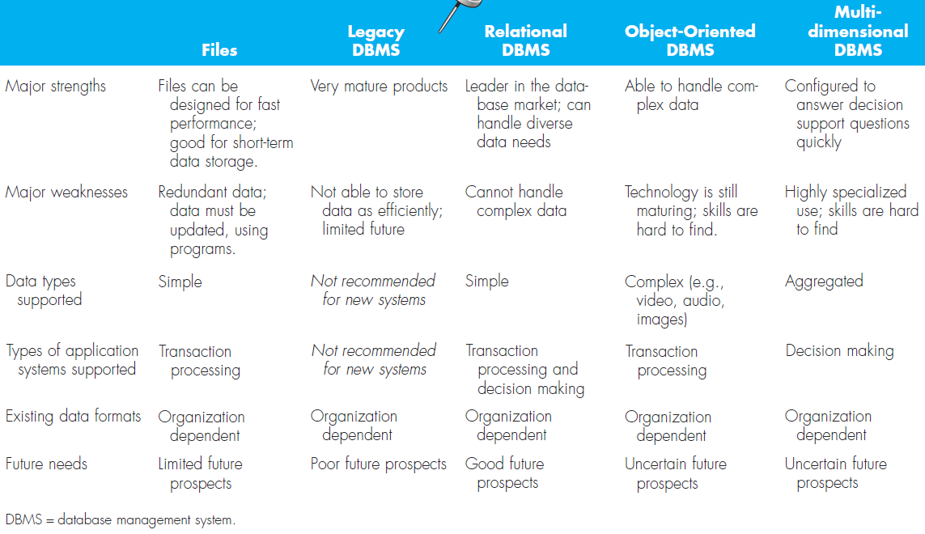

What do you mean about the Access Speed and explain two of them? IMPORTANT
- After you have optimized your data model design for data storage efficiency, the end result is data that is spread out across a number of tables
- There are several techniques that the project team can use to try to speed up access to data: “Are examples for Optimizing”
  - Denormalization
  - Clustering
  - Indexing
  - Estimating the size of data for hardware planning purposes

IMPORTANT
- Clustering: Reduce the number of times storage must be accessed by physically placing like records close together.
  - Intrafile clustering – similar records in a table are stored together
  - Interfile clustering – combine records from more than one table that are typically retrieved together
- Indexing: A mini-table that contains values from one or more fields in a table and the location of the values within the table
Similar to the index of a book.

